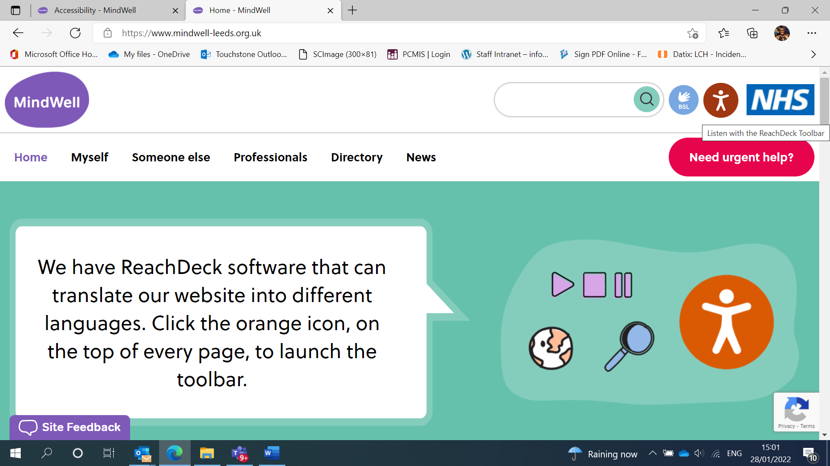

Type https://www.mindwell-leeds.org.uk/ into your browser and click on the top icon that looks like a person.
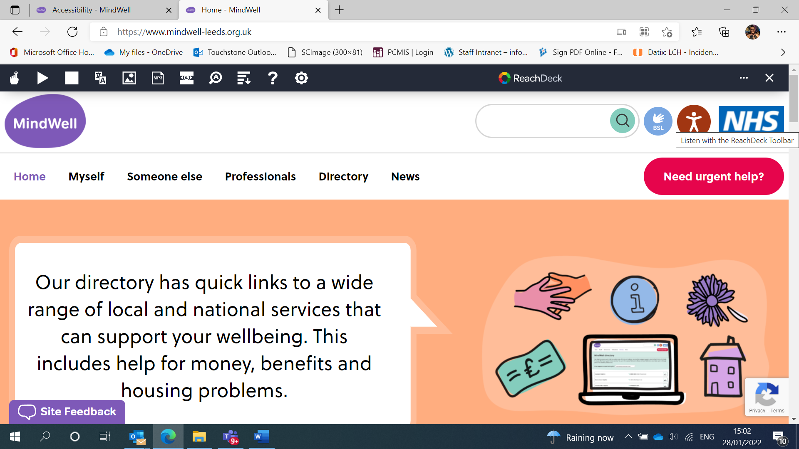

Once you have clicked on the icon that looks like a person you will see a black bar across the top of the screen with various buttons.
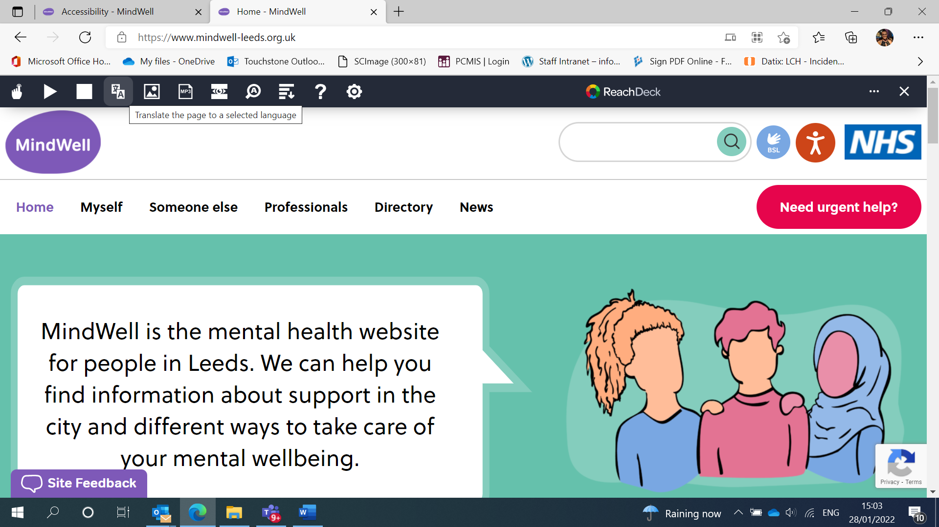
Click the fourth button along to translate the page into a selected language.
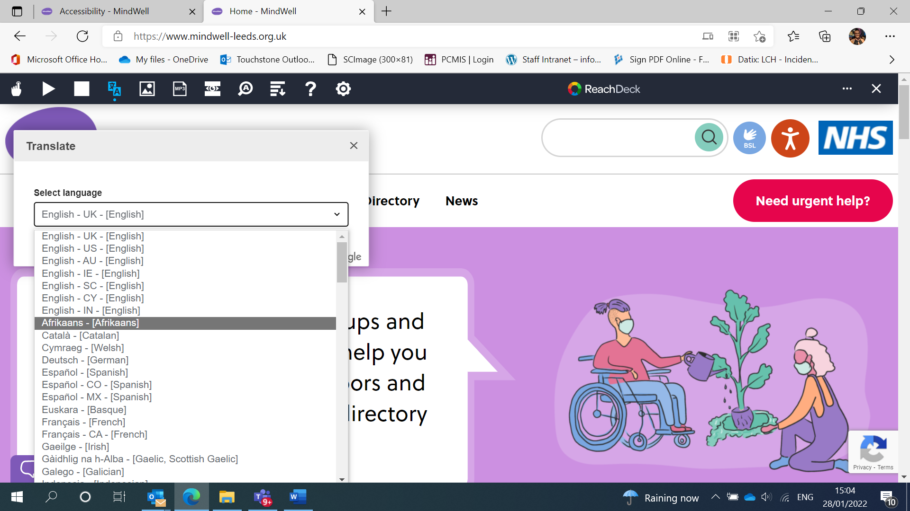
Select a language from the drop down menu.
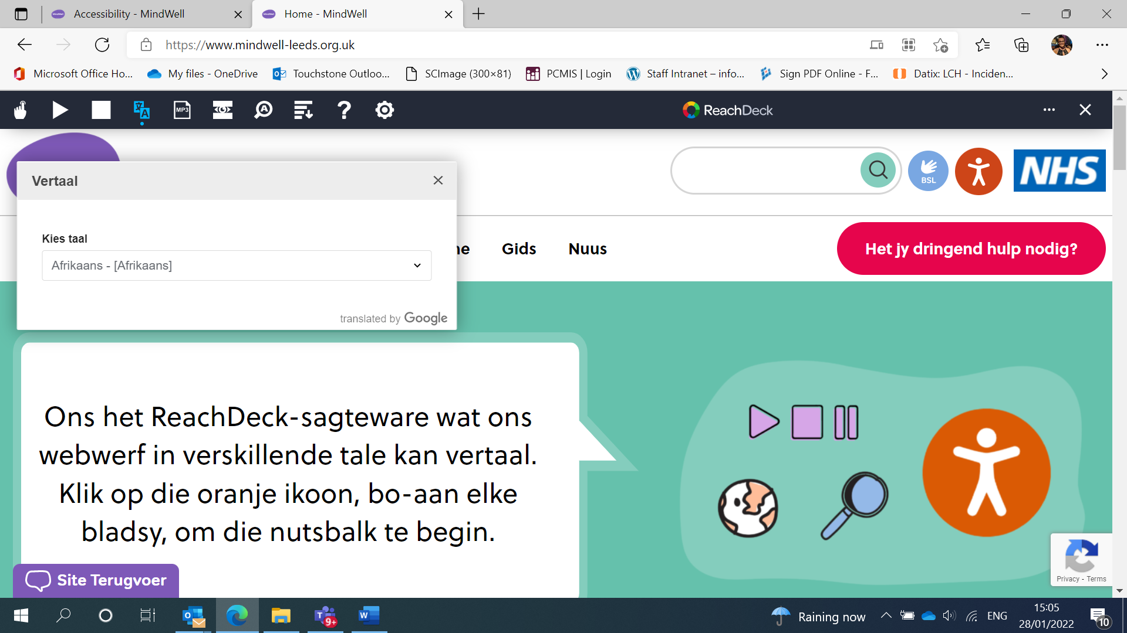
The website will then translate content into selected language.
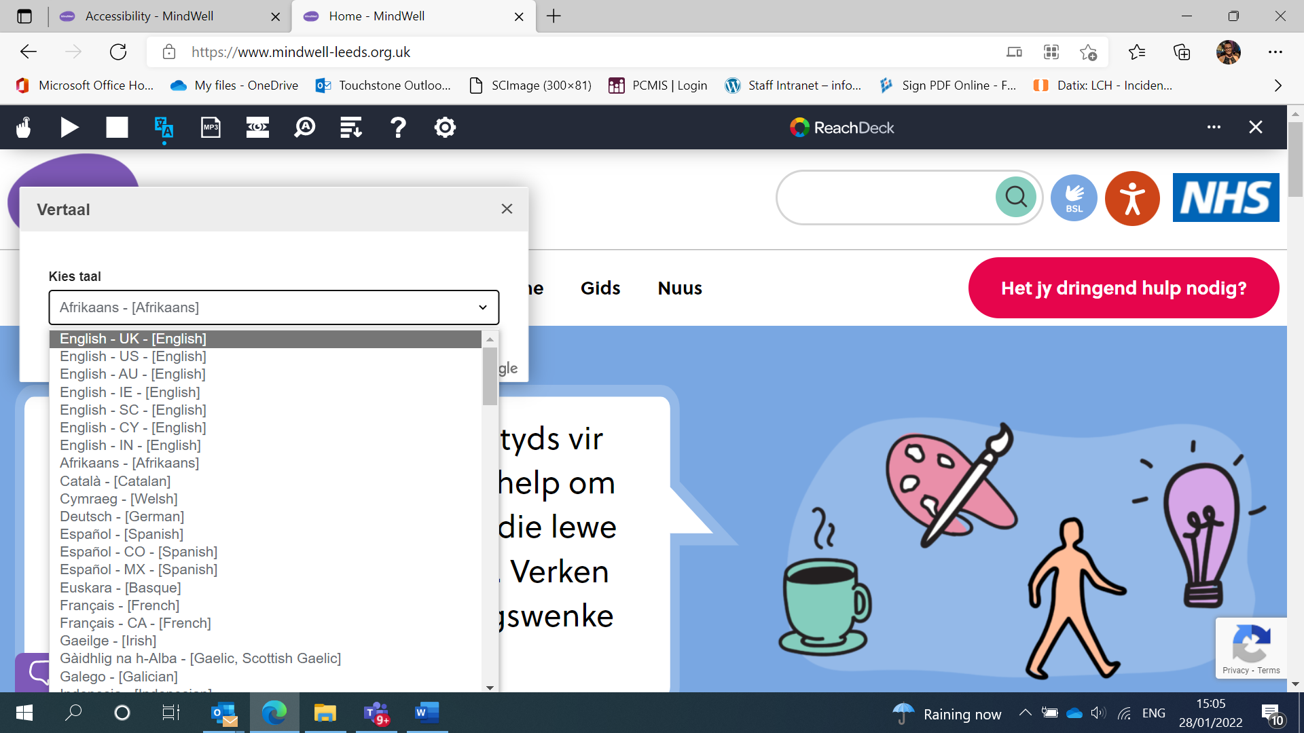
To go back to English or change to another language just select the language from the drop down menu.#

