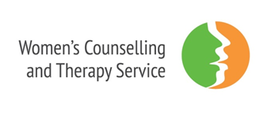
WCTS’s Perinatal Mental Health Service is a specialist service for women (and their female partners) who are pregnant, or who have been pregnant in the past 12 months, as well as for women who have, or care for an infant under one-year-old.
One to one therapy
Our therapists work with women to support them during the changes and challenges of the perinatal period. Therapy focuses on self-care, establishing a sense of safety, stabilisation and managing difficult emotions. We provide long term psychotherapy, usually for around 6 months, although we can work with some clients for longer than this. We offer face to face therapy and have a limited offer of remote therapy over Zoom for clients with disabilities or health conditions that make it impossible for them to attend an appointment in person. We may be able to pay for transport or childcare if this is a barrier to attending.
The types of issues we work with during pregnancy and the perinatal period are:
- Support during pregnancy
- Termination of pregnancy
- Miscarriage, stillbirth and infant loss
- Post Natal Depression
- Anxiety around pregnancy, birth and parenting
- Relationship issues
- Bonding with baby & attachment issues

Casework
Our Caseworker works with women to address practical barriers to accessing or sustaining therapy, such as housing crisis, benefits, or accessing specialist support services. The caseworker offers short term (around 3 months), focused work either prior to or alongside therapy. Professionals can refer directly into the casework service. The Caseworker offers appointments at the WCTS office, community venues and can visit clients at home. This service is only available to women in the perinatal period who want to access therapy.

Referrals
We specialise in working with women who can struggle to access, engage or recover in more mainstream services, and those who want/need to access a women’s service for reasons of experience (often gender-based violence and abuse), faith and or culture.
Referrals are made via our website https://www.womenstherapyleeds.org.uk/request-service/
We do not have a long waiting list due to the time crucial nature of work during the perinatal period.

